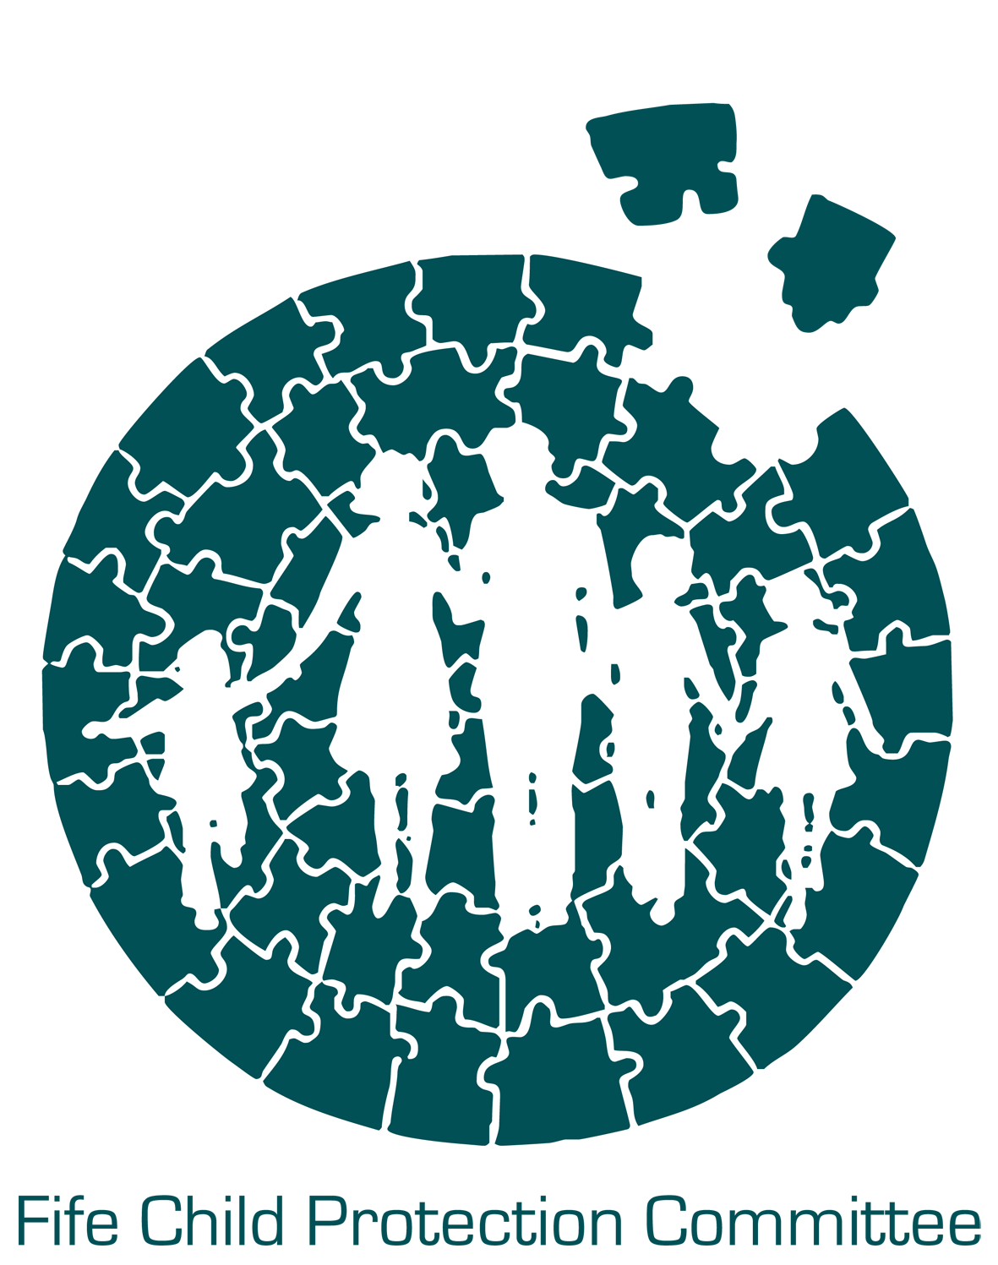

Fife Inter Agency Child Protection Training

01 April 2016 - 31 March 2017

The Inter Agency Child Protection Training Programme for 2016 – 2017 has been developed in line with the National Framework for Child Protection Learning and Development.

This programme is subject to change and any new dates or courses will be added to our website www.fifechildprotection.org.uk

Fife Council applicants
Fife Council Employees should book their places via the Corporate Learning Management System (CLMS) for all inter agency child protection courses.

Non-Fife Council applicants
Other partner agencies should book using the online booking form on our web page. Alternatively applications can be made directly to the Child Protection Committee Support Team, based in Police HQ, Glenrothes.
You can contact the CPC Support Team at 01592 583251 or by email
fife.childprotection@fife.gov.uk.

Training is held in the School of Nursing and Midwifery, Forth Avenue, Kirkcaldy KY2 5YS. Once your place has been confirmed you will receive an email with your classroom number. There is no reception at the college and no requirement to sign in on entry to the building. You should go straight to your allocated classroom where a register will be taken by the tutor.

Tea/coffee is provided at the breaks. Lunch is not provided but there is a facility at the college to purchase hot and cold snacks and drinks. There is also a microwave available to heat food items brought in by participants.

Fife Child Protection Committee continues to deliver inter agency child protection training free of charge. However, if you have to cancel a place on a course please contact the CPC Support Team as soon as possible; giving at least 3 working days’ notice, otherwise a charge may apply. Fife Council participants should cancel via the CLMS system.

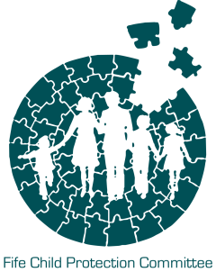 | Fife Child Protection Committee  Child Protection Training by Workforce Groups  1st April 2016 - 31st March 2017
This Training calendar should be read in conjunction with the Scottish Government National Framework for Child Protection Learning and Development in Scotland 2012 which outlines the competences/knowledge/skills required in the three workforce categories referred to in this calendar. In addition single agency training calendars should be considered by applicants. It is recognised that applicants’ needs will vary and as such they will wish to consider training opportunities outwith the workforce category that they may sit in. For example applicants from the General Contact Workforce can take up training in the Specific Contact Workforce list and vice versa.

The ‘General Contact’ Workforce

Those who as part of their job are likely to come into contact with children, young people and other family members. The frequency of contact will vary, but these workers will not usually be involved in any in-depth personal work with them. However, these workers need to have confidence and awareness to recognise when a child or young person may be in need of protection, and how to respond

The ‘Specific Contact’ Workforce

Those who carry out direct work with children, young people or other family members; and/or form more in-depth relationships with them; and/or provide specific services to them. These workers may carry out regular work with a child, young person or adult (although this will not always be the case). Contact may take place in the home or other setting (eg an office, school, community setting etc). It may involve one to one work, or work in a group. These workers may be asked to contribute to the risk assessment and risk management process and may be involved in providing ongoing support to some children, young people and family members. These workers require the competences, knowledge and skills associated with the general contact workforce, and some additional competences, knowledge and skills to reflect the nature of their involvement with children, young people and their families. This could include those acting as the Named Person or Lead Professional.

The ‘Intensive Contact’ Workforce

Those who have a specific designated responsibility for child protection issues as part of their role (eg where this is linked to their post, or where they are the Named Person or Lead Professional and/or those working with complex cases eg providing particular forms of support relating directly to child protection). These workers require the competences, knowledge and skills associated with the general and specific contact workforces, but need additional competences, knowledge and skills to carry out their tasks.

General Contact Workforce Training Courses
An Introduction to GIRFEC and Child Protection (1 day course)
Early Years Child Protection (1 day course)
Children’s Rights (half day course)
Neglect. What are we talking about? (1 day course)
Specific Contact Workforce
Workers should have completed courses for general workforce and/or be able to evidence the competences/knowledge/skills required within this category
An Introduction to the Child Protection Case Conference (1/2 day course)
Working Together to Safeguard Children (2 day Course)
Links between Domestic Abuse and Child Protection (1 day course)
Neglect. What are we talking about? (1 day course – under General)
Early Years Child Protection (1 day course – under General)
Children’s Rights (half day course – under General)
CPC Development Session (depending on topic area)
Annual Conference
Intensive Contact Workforce
Workers should have completed courses for general and specific workforce and/or be able to evidence the competences/knowledge/skills required within this category.
Training at this level will be generally be available through single agencies so please refer to service specific training opportunities. No inter agency courses currently available
All Contact Workforce Groups: E-learning
The e-learning courses below are available for all contact workforce groups.
SafetyNet E-learning (online course)
Protecting Children in Scotland E-learning (online course)

General Contact Workforce
An Introduction to GIRFEC and Child Protection (9.30 am – 3.30 pm)

Book via CLMS (Fife Council) or for non-Fife Council contact CPC Support Team at 01592 583251 fife.childprotection@fife.gov.uk or complete the online booking form

All dates will be delivered from: School of Nursing & Midwifery, Kirkcaldy
Aim

Participants will gain an awareness of issues which might give rise to concerns for children and what they and others can do about it.

Objectives

- Participants are aware of the main features of the ‘Getting it Right’ approach (GIRFEC).
- Participants understand the range of issues which might signify concerns for a child, including abuse.
- Participants know what to do about concerns for children in terms of GIRFEC and Child Protection processes.
- Participants have an understanding of the current guidance and processes which operate in terms of child welfare within Fife.

Learning Outcomes – on completion of this training participants should be able to:

- Identify a range of situations which might give rise to a concern including abuse
- Demonstrate what to do when aware of a concern for a child
- Define the roles, responsibilities and thresholds of key agencies in child welfare and protection
- Explain how the GIRFEC approach can be used to effect early support for children and families

Target Group

For all staff in the public, private and voluntary sectors, including those who have direct, indirect and/or occasional working contact with children, young people and families. It is also relevant to those working in adult services where there is a likelihood that their client base interacts with children.

Thursday 14th April 2016  Tuesday 3rd May 2016  Wednesday 1st June 2016  Thursday 16th June 2016  Monday 27th June 2016  Tuesday 30th August 2016  Thursday 15th September 2016 | Thursday 6th October 2016  Wednesday 2nd November 2016  Tuesday 22nd November 2016  Monday 5th December 2016  Monday 23rd January 2017  Tuesday 21st February 2017  Thursday 9th March 2017

General Contact Workforce / Specific Contact Workforce
Neglect. What are we talking about? (9.30 am – 3.30 pm)

Book via CLMS (Fife Council) or for non-Fife Council contact CPC Support Team at 01592 583251 fife.childprotection@fife.gov.uk. or complete the online booking form

All dates will be delivered from: School of Nursing & Midwifery, Kirkcaldy
Aim

To enable practitioners to better understand the impact of neglect on children and what options for engagement are likely to lead to more positive outcomes.

Objectives

- To explore how the various types of neglect impact on the development and wellbeing of children and young people
- To consider factors which might impact on parenting capacity, thus increasing the possible risk of neglect
- To examine how values, attitudes, parental engagement and thresholds can affect intervention in neglect cases
- To understand how agencies can address neglect through effective assessments and analysis

Learning Outcomes – on completion of this training participants should be able to:

- Identify a range of situations which might give rise to a concern including abuse
- Demonstrate what to do when aware of a concern for a child
- Define the roles, responsibilities and thresholds of key agencies in child welfare and protection
- Explain how the GIRFEC approach can be used to effect early support for children and families

Target Group

This is a one day introductory course aimed at all practitioners in the general workforce category who would be interested in a more detailed exploration of neglect and how it might impact on a child’s development and wellbeing.

Thursday 12th May 2016  Wednesday 29th June 2016  Tuesday 27th September 2016 | Thursday 24th November 2016  Wednesday 1st February 2017  Monday 27th March 2017

General Contact Workforce / Specific Contact Workforce
Early Years Child Protection (9.30 am – 3.30 pm)

Book via CLMS (Fife Council) or for non-Fife Council contact CPC Support Team at 01592 583251 fife.childprotection@fife.gov.uk. or complete the online booking form

All dates will be delivered from: School of Nursing & Midwifery, Kirkcaldy
Aim

The aim of this training is to offer staff who work with young children (0 to 5 years) an understanding of child protection in the early years context.

Objectives

- To inform about the Early Years Framework
- To raise awareness of the specific vulnerability of very young children
- To understand their role in keeping young children safe
- To explore good practice and the concept of engagement with parents
- To learn about local initiatives
- To learn about recording, referral and assessment procedures

Learning Outcomes – on completion of this training participants should be able to:

- Participants will have a better understanding of their role in child protection in the early years context
- Participants will have greater knowledge about the vulnerability of young children to abuse
- Participants will have greater knowledge about recording, referral and assessment procedures
- Participants will have more confidence in their work with families
- Participants will learn about local initiatives in the early years field.

Target Group

All staff involved in direct work with young children (0 to 5 years) and their parents e.g. midwives, health visitors, nursery staff, child minders, crèche workers, project workers.

Thursday 10th November 2016 | Thursday 23rd February 2017

General Contact Workforce / Specific Contact Workforce
Children’s Rights (9.30 am – 12.30 pm)

Book via CLMS (Fife Council) or for non-Fife Council contact CPC Support Team at 01592 583251 fife.childprotection@fife.gov.uk. or complete the online booking form

All dates will be delivered from: School of Nursing & Midwifery, Kirkcaldy
Aim and Objectives

To raise awareness of the key issues in relation to the rights of children in child protection, how they can exercise their rights and the responsibility of adults to uphold those rights.

Learning Outcomes - on completion of this training participants should be able to:

- Have an understanding of Children’s Rights in child protection work
- Be aware of the broader context of Children’s Rights work
- Have explored a range of attitudes in relation to this issue
- Be aware of their responsibilities to uphold Children’s Rights
- Be able to support children in exercising their rights

Target Group

All frontline staff and managers who work with children and families in the public, private and voluntary sectors including health, education, social work, police, housing, community services and the voluntary sector.

Tuesday 30 August 2016 | Tuesday 7 February 2017

Specific Contact Workforce
Introduction to the Child Protection Case Conference (9.30 am – 1.00 pm)

Book via CLMS (Fife Council) or for non-Fife Council contact CPC Support Team at 01592 583251 fife.childprotection@fife.gov.uk. or complete the online booking form

All dates will be delivered from: School of Nursing & Midwifery, Kirkcaldy
Aim

The aim of this training is to introduce participants to the purpose and function of the Child Protection Case Conference.

Objectives

- To consolidate participants’ understanding of the role and function of the Case Conference
- To allow them to consider their own role and contribution to the Case Conference
- To inform about how information is assessed within the Case Conference
- To inform about how decisions are reached within the Case Conference

Learning Outcomes - on completion of this training participants should be able to:

- Participants will have a better understanding of the purpose and function of the Case Conference and have a clear understanding of the expectations associated with their role
- Participants should feel more confident in applying their knowledge and skills while attending and participating in a Child Protection Case Conference

Target Group

All frontline staff and managers in the public, private and voluntary sectors including health, education, social work, police, housing, community services and the voluntary sector who may be invited to attend a Child Protection Case Conference

Tuesday 7th June 2016  Monday 19th September 2016 | Thursday 8th December 2016  Friday 24th March 2017

Specific Contact Workforce
Working Together to Safeguard Children (2 days: 9.30 am – 3.30 pm)

Book via CLMS (Fife Council) or for non-Fife Council contact CPC Support Team at 01592 583251 fife.childprotection@fife.gov.uk. or complete the online booking form

All dates will be delivered from: School of Nursing & Midwifery, Kirkcaldy

This course considers some of the major learning points which have arisen from child death inquiries and serious case reviews. The factors identified will be discussed in the context of assessing a child’s situation and what might influence communication and decision making when interacting with other professionals, children and parents. Throughout the course, a focus remains on the current implementation of the ‘Getting it Right’ agenda (GIRFEC).

Aim
To enhance the degree to which participants communicate and cooperate when contributing to situations where concerns have been raised for a child.

Objectives

- To explore some common themes raised during child death inquiries and significant case reviews.
- To promote partnership and collaborative working by increasing awareness of issues relevant to communication in child welfare practice.
- To stimulate effective cooperation by increasing awareness of the Fife Child Wellbeing Pathway and how this relates to both GIRFEC and the Child Protection approaches.

Learning Outcomes – On completion of the course participants will be able to:-

- Describe what constitutes sound communication practice within the context of child welfare practice
- Identify some of the dynamics which influence assessment and decision making
- Define the principles of information sharing
- Contribute to an effective single agency assessment and chronology as part of the Fife child wellbeing pathway.

Target Group
For all frontline staff and managers in the public, private and voluntary sectors; including those who have direct, indirect and/or occasional working contact with children, young people and families. It is also relevant to those working in adult services where there is a likelihood that their client base interacts with children. Ideally, participants should already have some basic awareness of child protection issues.

Monday/Tuesday 25th/26th April 2016  Wednesday/Thursday 25th/26th May 2016  Tuesday/Wednesday 21st/22nd June 2016  Tuesday/Wednesday 23rd/24th August  Monday/Tuesday 5th/6th September 2016 | Thursday/Friday 27th/28th October 2016  Thursday/Friday 17th/18th November 2016  Tuesday/Wednesday 17th/18th January 2017  Monday/Tuesday 27th/28th February 2017  Thursday/Friday 16th/17th March 2017

Specific Contact Workforce
Links between Domestic Abuse and Child Protection (9.30 am – 4.30 pm)

Book via CLMS (Fife Council) or for non-Fife Council contact CPC Support Team at 01592 583251 fife.childprotection@fife.gov.uk. or complete the online booking form

All dates will be delivered from: School of Nursing & Midwifery, Kirkcaldy

Aim

To build a solid understanding of the nature and scope of domestic abuse and its intersections with child protection, providing the delegates with the confidence and knowledge to deal with the issue effectively in their work setting.

Objectives

- Understand domestic abuse as pattern of coercively controlling behaviours within which children are actors not witnesses.
- Appreciate the impact of domestic abuse on those who experience it and perpetrate it and how it affects their behaviour and choices.
- Consider the implications for safe service interventions with families where domestic abuse is an issue.
- Identify key practice messages from the National Guidance for Child Protection in Scotland as it relates to domestic abuse interventions.

Learning Outcomes

- Increased awareness of links between domestic abuse and child protection.
- Staff will be more confident and competent in recognising, sharing and responding to concerns where children are affected by domestic abuse.

Target Group

All frontline staff and managers in the public, private and voluntary sectors including health, social work, education, police, housing, community services and the voluntary sector.

Wednesday 4th May 2016  Tuesday 6th September 2016 | Tuesday 29th November 2016  Tuesday 24th January 2017

All Contact Workforce Groups: E-learning
Protecting Children in Scotland E-learning

This online course has 4 modules:

- An introduction to Child Protection
- Recognising Child Abuse and Neglect
- Child Protection in Practice
- The Child Protection Process

All 4 modules should be completed.

This online course is open to staff both within and external to Fife Council. Access to this is through the Social Work Services: Workforce Planning and Development Portal. Please follow the steps below:

- Open the website http://socialwork.fife.gov.uk/
- Click on the icon ‘Multi Agency Resources’
- Click on the link ‘Protecting Children in Scotland E-learning’ (you may be asked to agree to an internet netiquette)
FOR Fife Council Employees:

- Click on the link ‘here’ NOT the picture icon – this will redirect you to Learning Nexus and you should login using your Fife Council E-learning details (payroll number and password)
- You will then have the option to complete the course with or without audio.
- You need to complete all 4 modules and the Final Assessment. Please keep a print out of the page with your Final Assessment results as evidence of completion.
FOR Non-Fife Council Employees

- Click on the ‘Protecting Children in Scotland E-learning’ picture icon
- You will then have the option to complete the course with or without audio
- Check the button for ‘normal’ mode is selected, before clicking on ‘Enter’
- Once you have completed the 4 modules and the Final Assessment, print the page with your results as evidence of completing this course. You must complete the course in one sitting as progress will not be saved.

All Contact Workforce Groups: E-learning
SafetyNet E-learning

This SafetyNet E-learning module is aimed at practitioners working with children and young people. The short e-learning module was created by members of Fife’s Internet Safety Group in conjunction with Digital Fife.

The aim of this e-learning module is to improve basic awareness of internet safety, giving staff the confidence to discuss internet safety issues with young people and families.

To access the e-learning click on the link below:

SafetyNet E-learning

Or type http://safetynet.digitalfife.com/Index.asp?ID=441 into your internet browser.

NB: If you wish to make full use of this resource and view the film clips you need to be able to have sound and access to YouTube. If you are a Fife Council employee this would need to be accessed through Google Chrome.

You can download Google Chrome by clicking here

Registration is quick and easy and the module should take approximately an hour to complete.

Please print your certificate on completion as evidence of completing this successfully.

